**سؤال :- أضف الى كلاس الvehcil الشركة التي صنعتها و السنة الموديل و السرعة و من ثم عل تغليف أنكبسليشن عليهم ثم أستخرج من بين السيارتين هي أحدث**

**الكلاس الفعال**

package vehcil;

public class vehcil {

private int passengers;

private int fuelcap;

private int mpg;

private String make ;

private int yearmodel ;

private int topspeed;

public int range() {

return mpg*fuelcap;

}

double fuelneeded(int miles) {

return (double) miles / mpg;

}

vehcil (int p,int f,int m , String ma, int y , int t){

this.passengers=p;

this.fuelcap=f;

this.mpg= m;

this.make=ma;

this.yearmodel=y;

this.topspeed=t;

}

public int getpassengers() {

return

passengers;

}

public void setPassengers(int passengers) {

this.passengers = passengers;

}

public int getfuelcap() {

return

fuelcap;

}

public void setfuelcap(int fuelcap) {

this.fuelcap = fuelcap;

}

public int getmpg() {

return

mpg;

}

public void setmpg(int mpg) {

this.mpg=mpg;

}

public String getmake () {

return

make ;

}

public void setmpg(String make) {

this.make=make;

}

public int getyearmodel() {

return

yearmodel;

}

public void setyearmodel(int yearmodel) {

this.yearmodel=yearmodel;

}

public int gettopspeed() {

return

topspeed;

}

public void setytopspeed(int topspeed) {

this.topspeed=topspeed;

}

public String toString (){

return

passengers+" "+ fuelcap+" "+mpg+ " "+make+" "+yearmodel+" "+topspeed ;

}

}

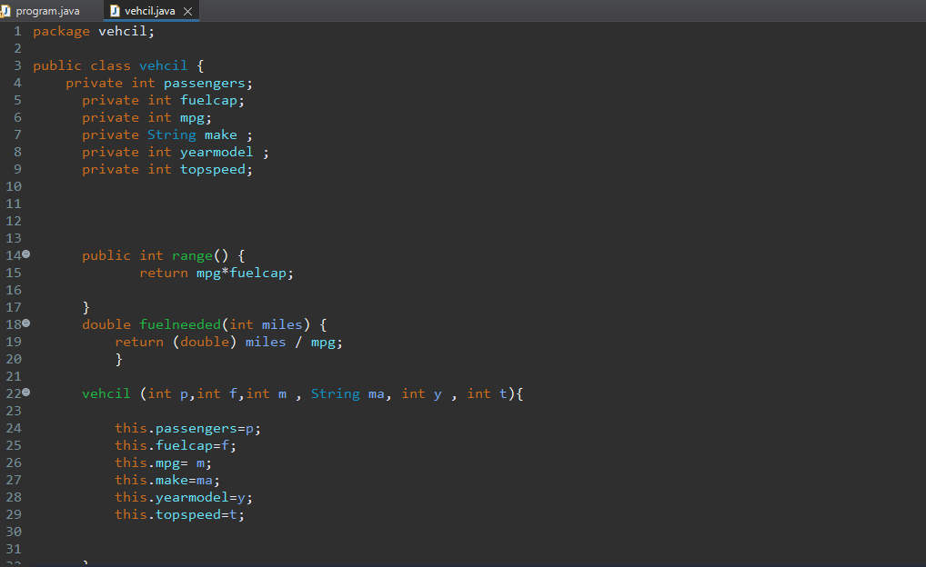

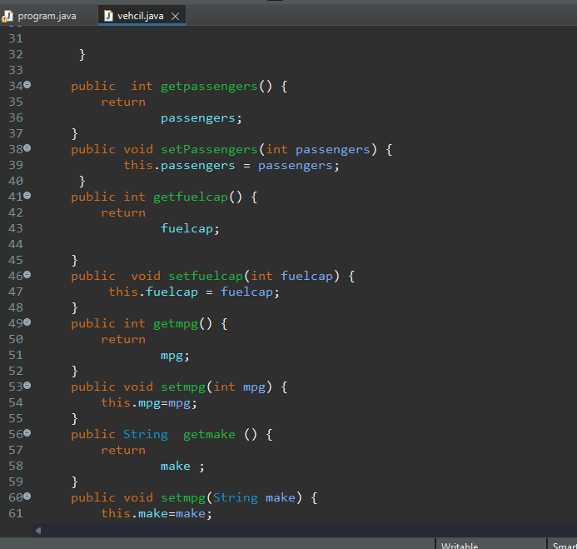

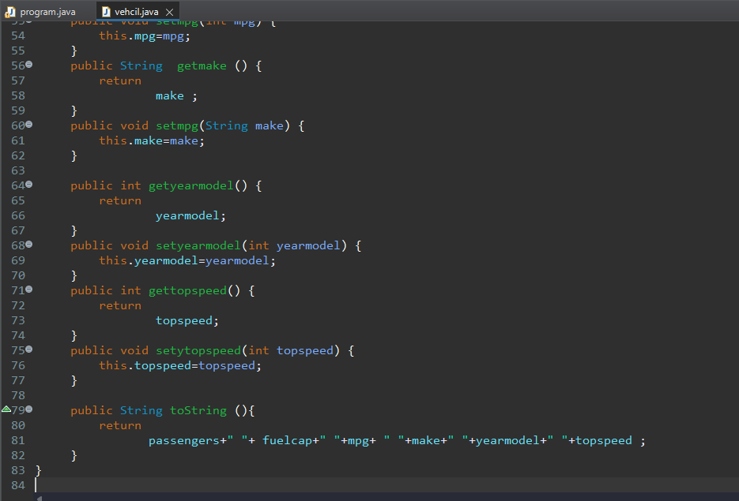**الكلاس الرأيسي**

package vehcil;

import java.io.ObjectInputStream.GetField;

public class program {

public static void main(String[] args) {

// **TODO** Auto-generated method stub

vehcil minivan = new vehcil(7,16,21,"mmd",2021,300);

vehcil sportcar= new vehcil(8,22,30,"ndd",2022,600);

if (minivan.getyearmodel()> sportcar.getyearmodel() ) {

System.***out***.println(minivan);

}else {

System.***out***.println( sportcar);

}

System.***out***.println("the passengers :"+minivan.getpassengers()+"the fuelcap :"

+minivan.getfuelcap()+"the mpg :"+minivan.getmpg() + "the make :"+minivan.getmake()+

"the yearmodel :"+minivan.getyearmodel()+"the topspeed :"+minivan.gettopspeed());

System.***out***.println(minivan);

System.***out***.println("the passengers :"+sportcar.getpassengers()+

"the fuelcap :"+sportcar.getfuelcap()+"the mpg :"+sportcar.getmpg()+ "the make :"+sportcar.getmake()+

"the yearmodel :"+sportcar.getyearmodel()+"the topspeed :"+sportcar.gettopspeed());

System.***out***.println(sportcar);

}

